Assignment 2
KG 573: Foundations of Database

Part A: 1NF, 2NF, 3NF

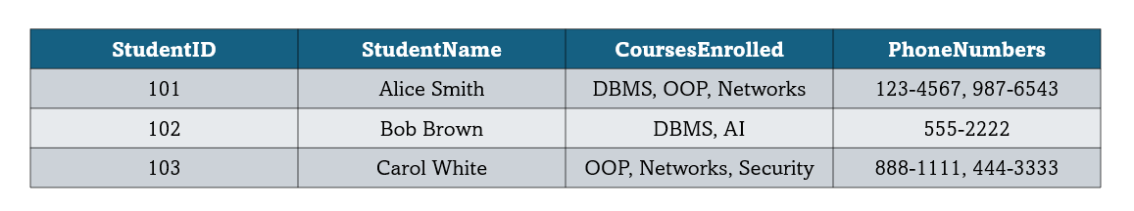
Task 1: Consider the following Student table. (1NF)

- Identify the problems in this table that violate the rules of First Normal Form (1NF). Explain clearly which aspect of 1NF is being violated and why.
- Normalize the Student table into 1NF. Provide the resulting relation(s) and a short explanation of how the changes improve data organization.

Task 2: Consider the following Enrolment Table. (2NF)
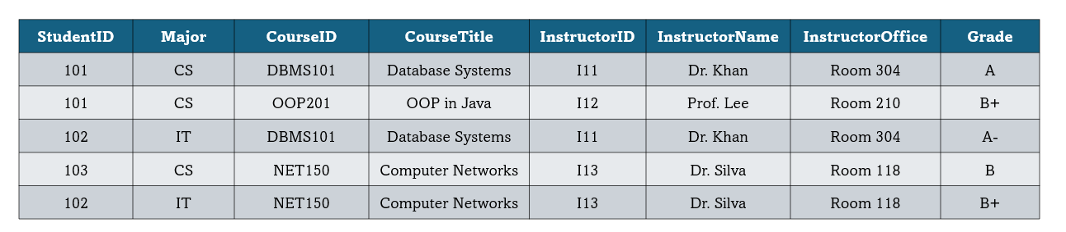
Note: A student can enrol in many courses, and a course has many students.

- Identify the primary key for the Enrolment table and justify your choice.
- List all the functional dependencies that hold in this table.
- Decompose the table into Second Normal Form (2NF). Provide the resulting relations and briefly explain how the decomposition removes partial dependencies.

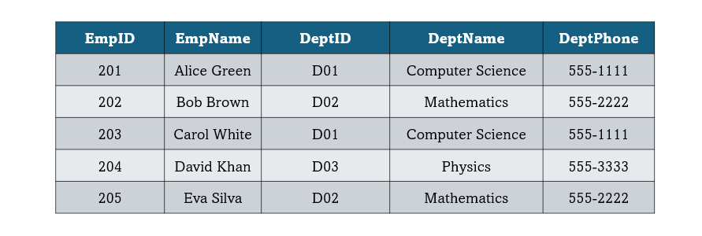
Task 3: Consider the following Table. (3NF)

- List the non-trivial functional dependencies implied by the notes and the data.
- Decompose the table into Third Normal Form (3NF). Provide the resulting relations and explain why the final set of relations is in 3NF.

Part B: BCNF, 4NF, 5NF
Task 1: Consider the following table. (BCNF)
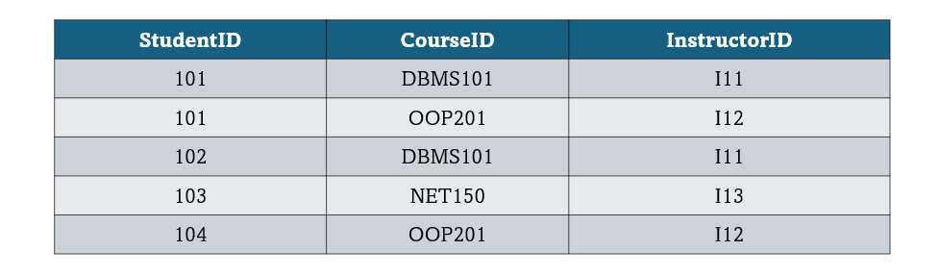

- Identify all functional dependencies in the table.
- Determine whether the table is in Boyce-Codd Normal Form (BCNF). If not, decompose it into BCNF relations.
- Show the final set of relations in BCNF and explain why they satisfy the BCNF requirements.

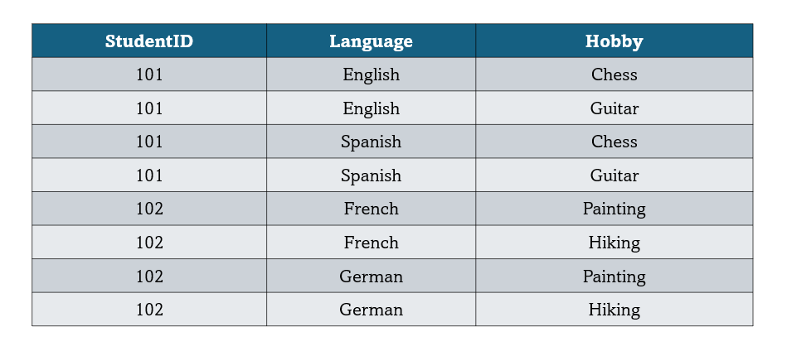
Task 2: Consider the following Table. (4NF)

- Identify the multivalued dependencies (MVDs) that exist in this table.
- Explain why these MVDs violate Fourth Normal Form (4NF).
- Decompose the table into 4NF relations. Provide the final relations and explain how the decomposition resolves the violation.

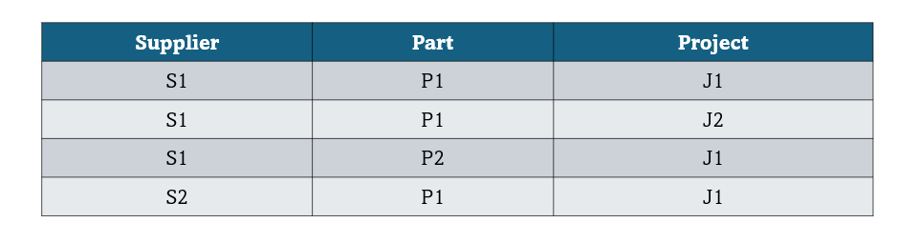
Task 3: Consider the table. (5NF)

- Identify the join dependency in the Contract relation.
- Explain why the table is not in Fifth Normal Form (5NF).
- Decompose the Contract table into 5NF relations. Provide the final set of relations and explain how they satisfy 5NF.

